**PELTON WHEEL**

**OBJECTIVE:**

To conduct performance test on Pelton wheel

**Apparatus used:**

Pelton wheel setup with centrifugal pump, pressure gauges, weighing balance weights, stop watch, measuring scale.

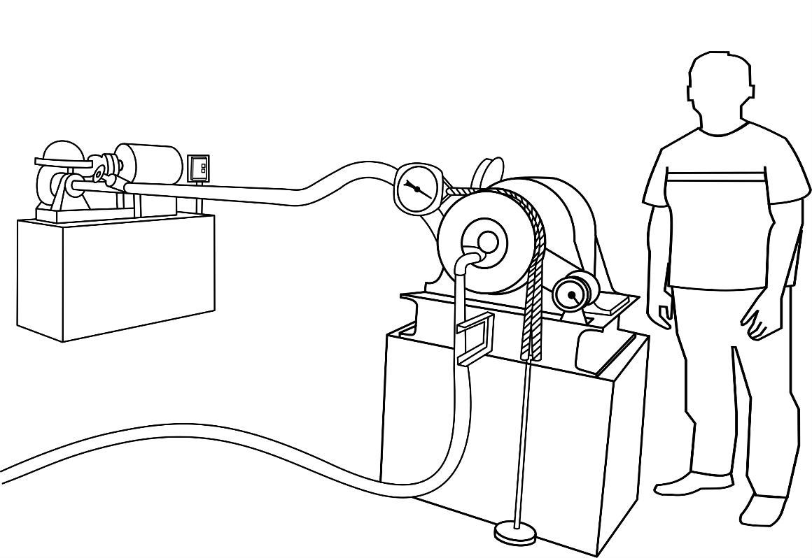

**Constant head:**

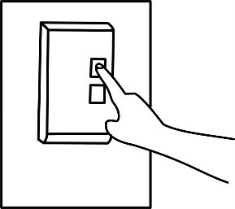**STEP:➊** Start the pump by pressing the button. Set the head of water to be constant.

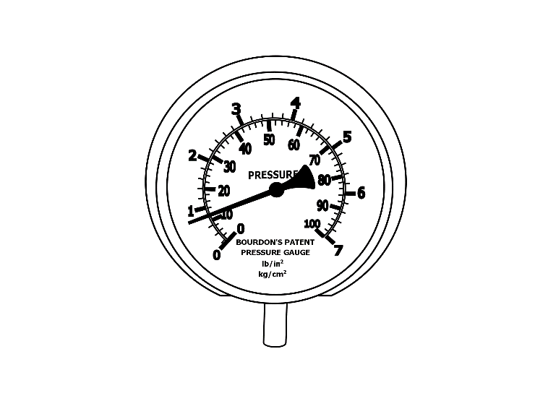 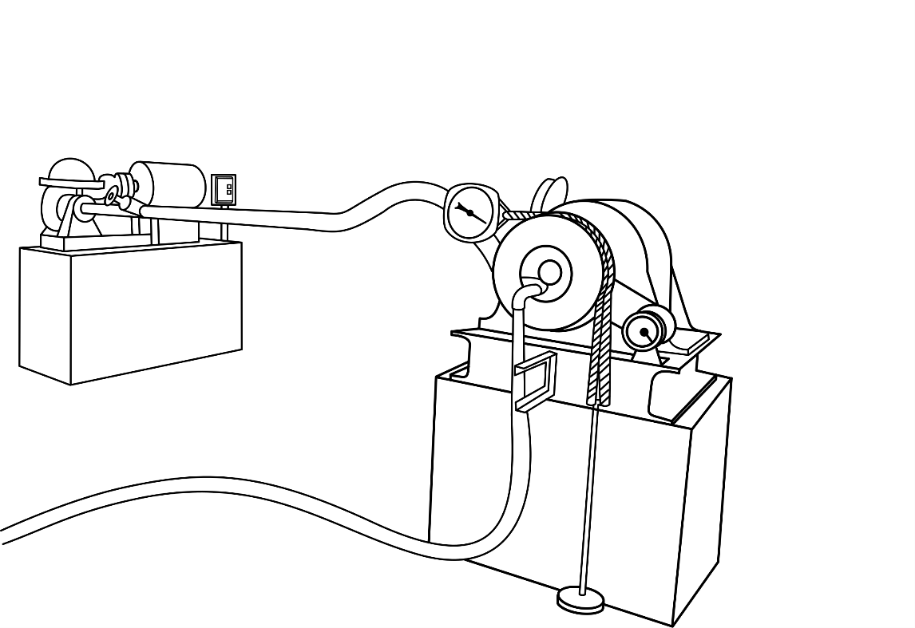

Constant head =_____kg/cm2

Constant head =_____m

**STEP:❷**  Apply the weight on the pan note the spring balance reading for the corresponding applied weight.

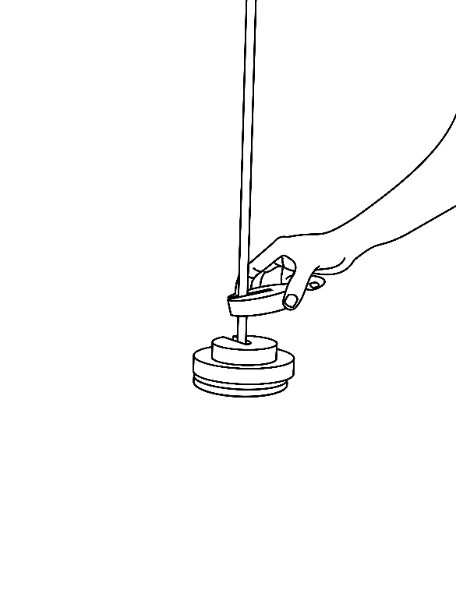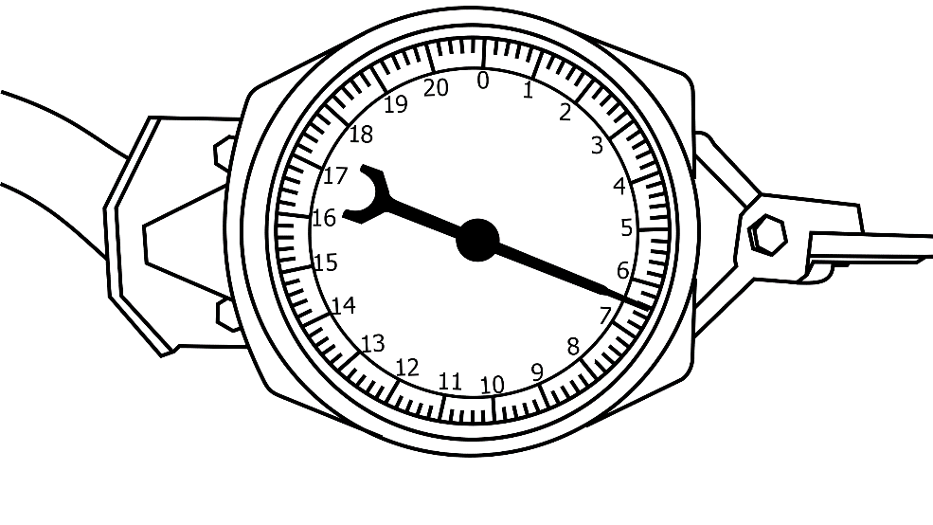.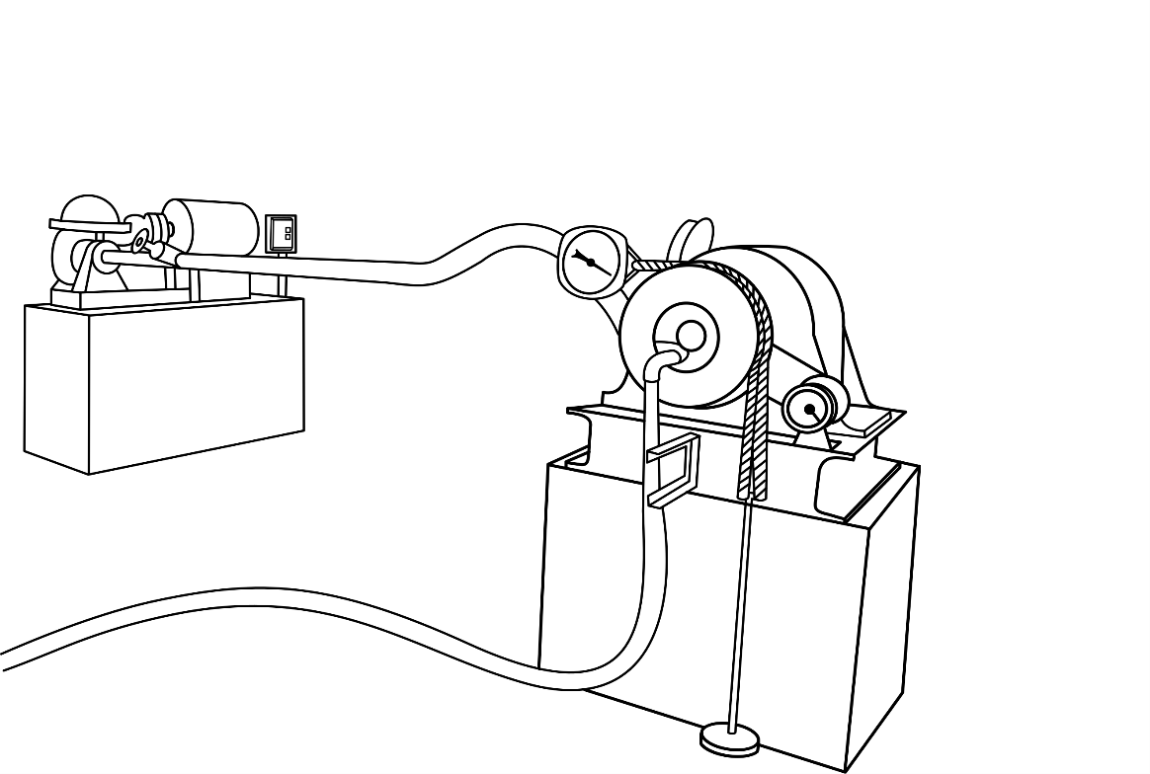

Weight on the pan=_____kg

Spring balance reading=_____kg

Torque=_____N-m

**STEP:➌** Note the speed of the motor.

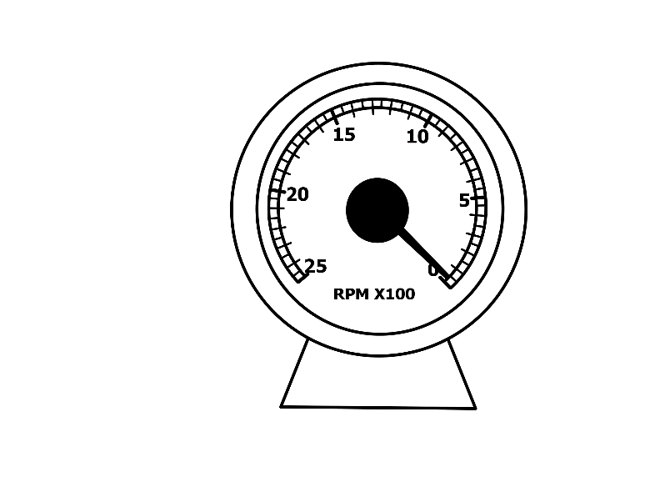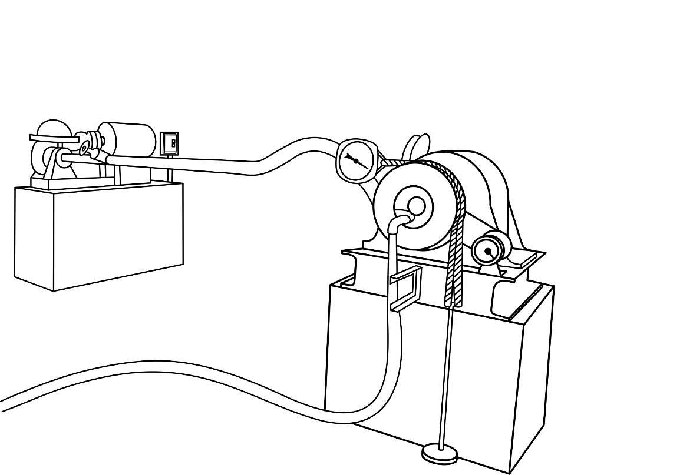

Speed of motor=_____rpm

**STEP:➍** Note the V- notch reading to find the discharge.

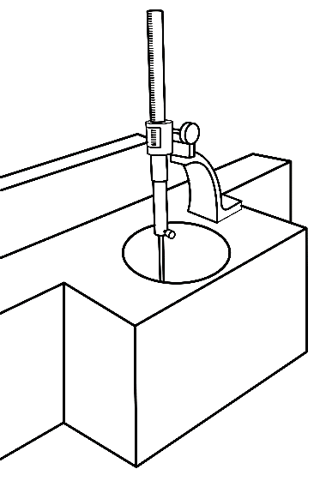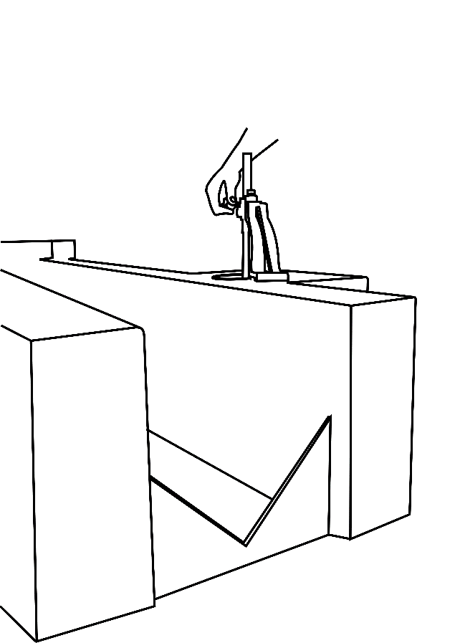

Initial reading (water level till crest) =_____

Final reading=_____

Head of water=_____

Actual discharge, Qact=_____m3/sec

**STEP:➎**

**Result**

Input power=_____watt

Output power=_____watt

Efficiency=_____%

Unit power=_____watt

Unit speed=_____rpm

Unit discharge=_____m3/sec

**Constant speed:**

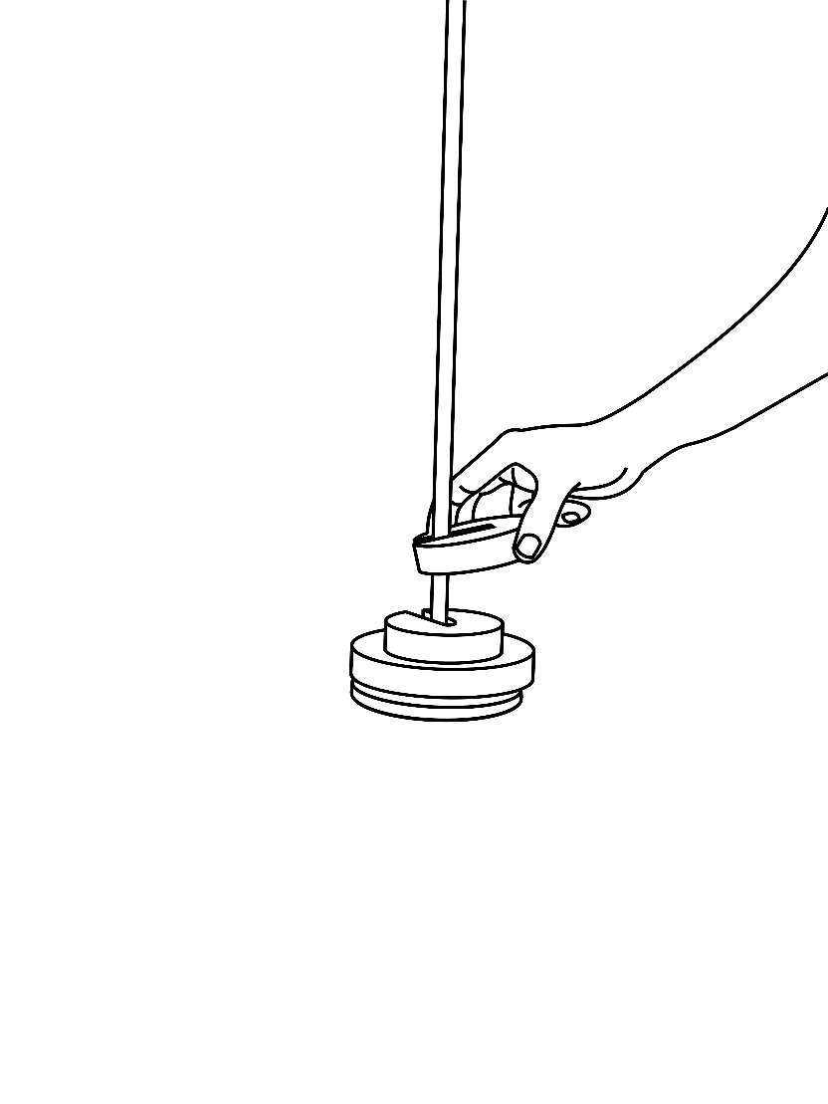**STEP:➏** Apply the weight on the pan. Note the weigh balance reading for the corresponding applied weight.

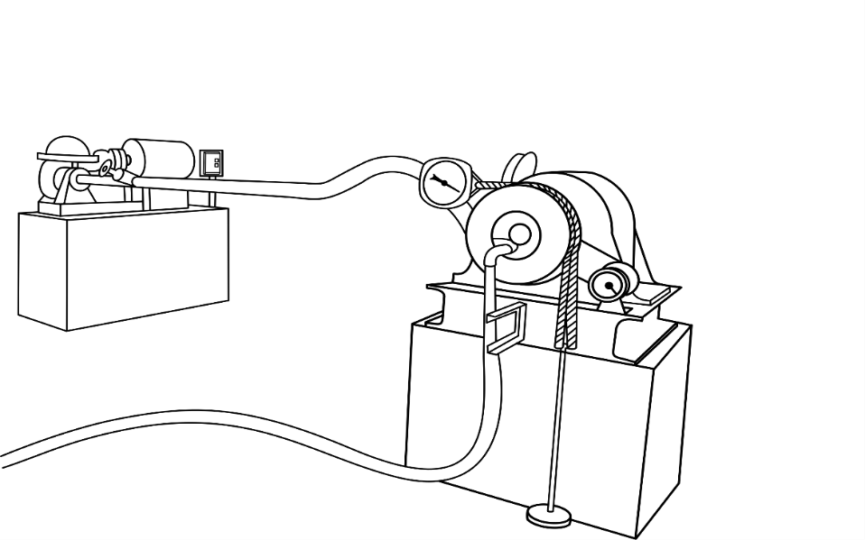



Weight on the pan=_____kg

Spring balance reading=_____kg

Torque=_____N-m

**STEP:➐** Set the speed of motor to be constant.

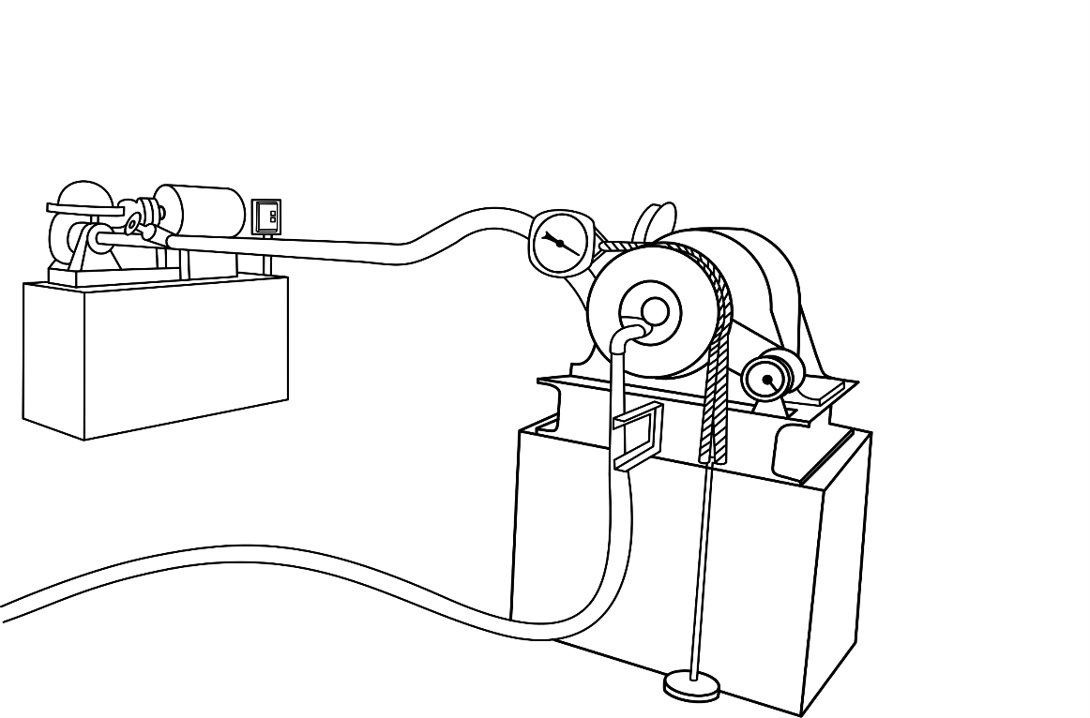

Speed of water=_____rpm

**STEP:➑** The head reading is noted down.

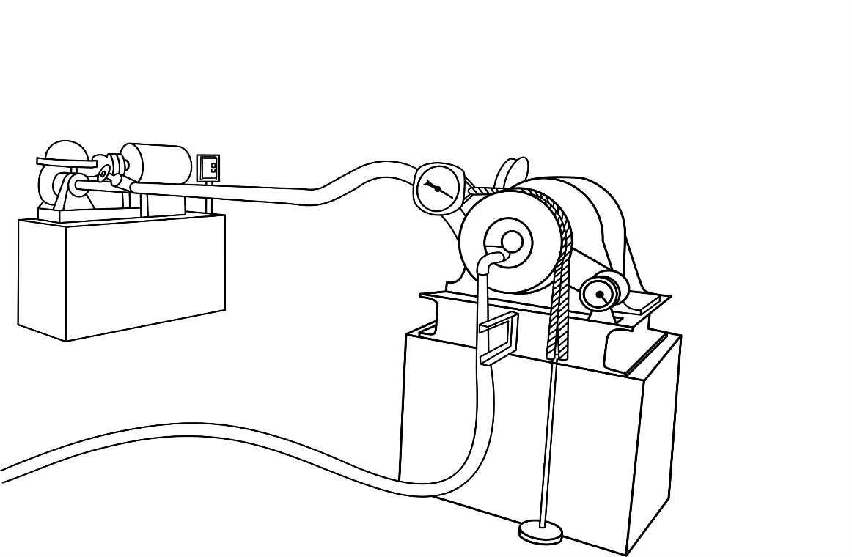

Head of water, H=_____kg/cm2

Head of water, H=_____m

Total head, H+z=_____m

**STEP: ❾** The V- notch reading is noted down to find the discharge.



Initial reading (water level till crest) =_____

Final reading=_____

Head of water=_____

Actual discharge, Qact=_____m3/sec

Input power=_____watt

Output power=_____watt

Efficiency=_____%

|  |  |  |  |  |  |  |  |  |  |  |  |  |  |  |
| --- | --- | --- | --- | --- | --- | --- | --- | --- | --- | --- | --- | --- | --- | --- |
| Sr. No. | Speed  (rpm) | Weight | | Torque  (N-m) | V-notch | | | Actual discharge,  (m3/sec) | Input power  (watt) | Output power  (watt) | Efficiency | Unit power  (watt) | Unit speed  (rpm) | Unit discharge    (m3/sec) |
| Pan  (w) kg | Spring  (s) kg | I.R | F.R | I.R-F.R |
| 1 | 975 | 1.8 | 0.6 | 1.77 | 0.52 | 9.78 | 9.26 | 3.697x10-3 | 736.96 | 180.72 | 24.52 | 1.97 | 216.3 | 0.82x10-3 |
| 2 | 900 | 2.8 | 0.9 | 2.796 | 263.52 | 35.76 | 2.88 | 199.7 |
| 3 | 850 | 3.8 | 1.2 | 3.826 | 340.56 | 46.21 | 3.72 | 188.56 |
| 4 | 800 | 4.8 | 1.6 | 4.709 | 394.5 | 53.53 | 4.31 | 177.47 |
| 5 | 775 | 5.8 | 2.4 | 5.003 | 406.03 | 55.1 | 4.43 | 171.92 |
| 6 | 675 | 6.8 | 2.9 | 5.739 | 405.66 | 55.04 | 4.42 | 149.74 |
| 7 | 600 | 7.8 | 3.1 | 6.916 | 434.55 | 58.96 | 4.74 | 133.1 |
| 8 | 500 | 8.8 | 3.2 | 8.24 | 431.44 | 58.54 | 4.71 | 110.92 |

Constant head:

Constant speed:

|  |  |  |  |  |  |  |  |  |  |  |  |  |  |
| --- | --- | --- | --- | --- | --- | --- | --- | --- | --- | --- | --- | --- | --- |
| Sr. No. | Head  (kg/cm2) | Head, H  (m) | Total head  Ht=H+z  (m) | Weight | | Torque (N-m) | V-notch | | | Actual discharge,   (m3/sec) | Input power  (watt) | Output power (watt) | Efficiency |
| Pan  (w) kg | Spring  (s) kg | I.R | F.R | I.R-F.R  (h) |
| 1 | 2 | 20 | 20.32 | 8.8 | 3.1 | 8.388 | 0.52 | 9.78 | 9.26 | 3.697 | 736.96 | 439.19 | 59.59 |
| 2 | 1.9 | 19 | 19.32 | 7.8 | 2.4 | 7.95 | 0.52 | 9.66 | 9.14 | 3.578 | 678.14 | 416.26 | 61.38 |
| 3 | 1.8 | 18 | 18.32 | 6.8 | 1.9 | 7.21 | 0.52 | 9.6 | 9.08 | 3.52 | 632.62 | 377.51 | 59.67 |
| 4 | 1.7 | 17 | 17.32 | 5.8 | 1.6 | 6.18 | 0.52 | 9.36 | 8.84 | 3.292 | 559.34 | 323.58 | 57.85 |
| 5 | 1.5 | 15 | 15.32 | 4.8 | 1.2 | 5.29 | 0.52 | 8.24 | 8.72 | 3.182 | 478.2 | 276.98 | 58.03 |
| 6 | 1.3 | 13 | 13.32 | 3.8 | 1.0 | 4.12 | 0.52 | 8.99 | 8.47 | 2.959 | 386.65 | 220.44 | 57.01 |
| 7 | 1.1 | 11 | 11.32 | 2.8 | 0.6 | 3.23 | 0.52 | 8.7 | 8.18 | 2.712 | 301.17 | 169.12 | 56.15 |
| 8 | 1 | 10 | 10.32 | 1.8 | 0.4 | 2.06 | 0.52 | 8.23 | 7.71 | 2.34 | 236.1 | 107.86 | 45.53 |

Characteristic graphs:

Constant head

Constant speed

Constant head:

Radius of brake drum(r) =15 cm

Initial weight of pan =1.8 Kg

Gate opening = 50 %

Constant head = m

Elevation difference (z) =_____m

Total head, HT=H+z =_____m

CALCULATION:

Constant head =_____m

Torque, 

=_____Nm

V-notch reading, I.R =_____ cm

F.R =_____ cm

I.R-F.R (h) =_____cm

Actual discharge, 

=_____m3/sec

Input power 

=_____W

Output power 

=_____W

Efficiency, 

=_____%

Unit power, 

=_____W

Unit speed, 

=_____rpm

Unit discharge, 

=_____m3/sec

Constant speed:

Radius of brake drum, r = 15 cm

Initial weight of pan = 1.8 Kg

Gate opening = 50 %

Constant speed, N =_____rpm

Torque, 

=_____N-m

V-notch reading, I.R =_____cm

F.R =_____cm

I.R-F.R (h) =_____cm

Actual discharge, 

=_____m3/sec

Input power 

=_____W

Output power 

=_____W

Efficiency, 

=_____%